Wanted: A media environment that supports democracy
Jan Rivers
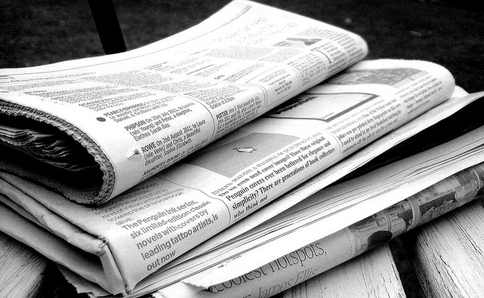
Several months ago I pursued a press complaint about an opinion piece published on the Stuff website by Journalist Pattrick Smellie. It was about the Trans-Pacific Partnership Agreement (TPPA) and his main point was that the TPPA does not pose a threat either to New Zealanders or to New Zealand’s democracy. It was sufficiently one-sided that a robust point by point rebuttal was published on the Public Address website. My complaint was not upheld. The serious risks presented by TPPA and similar agreements are beginning to attract much greater media attention. What we might expect from our journalists to help us in being informed and assessing our politicians?
Even before the Dirty Politics revelations there are many reasons why the media in NZ (and elsewhere) is not working well to support democracy. Three pieces of work show that the problems with the media go way beyond bias to the Right of the Left and cause us all to be poorly informed if not downright confused and disengaged. Psychologist Daniel Kahneman and philosopher Onora O’Neill have both written about bias and the formation of opinions. Nicky Hager addressed the issue of propaganda in NZ in a speech from 2007.
A significant problem is to do with whether we are able to make sense of the news media we receive. Kahneman is a Nobel Prize winner and his 2011 book “Thinking fast and slow” was the culmination of his life’s work and it’s an impressive but in some ways a depressing read. He discusses the many ways our thinking and behaviour is subject to unconscious bias and influence.
Kahnemann proposes that human beings think in different modes. Fast thinking is the kind of socially intuitive at ease thinking that we do in conversation with friends. It feels creative, comfortable and straightforward. Slow thinking in contrast is the kind of thinking that requires deep deliberation, a high level of concentration, a focus on examining the evidence and can be time consuming and tiring. It’s the kind of thinking for writing essays or carrying out a statistical analysis or deciding on the correct approach to a complex problem.
Life is simply too short to apply the kind of slow thinking required for rigorous analysis to the day to day issues that arise in our lives. The news is a prime example. The corresponding problem with fast thinking is that if information seems familiar we often make judgements that are simplistic and wrong. If it’s too hard we often substitute a simpler question for one we don’t understand. We are often overly influenced by associated information – a particular colour or typeface, a likeable face, the context set in a previous paragraph. Fast thinking judgments may feel familiar but they can easily be faulty and misleading. (The references below include several examples of this process but if you have ever responded to an email that asks a series of questions and then you end up identifying a red hammer you will have an inkling of how easy the fast-thinking mind is to fool).
The frequent repetition of terms like ‘comfortable about’, ‘dog whistle’, ‘talking down New Zealand’ or ‘union thugs’ are examples of powerful phrases used by the government to set the context of the debate on their terms. The use of carefully crafted sound-bytes, work-shopped by focus groups, scrutinised by marketing experts and using psychological techniques intended to bypass our critical awareness. When reporting uncritically quotes the terms that have been engineered to create a specific mind-set it does us no favours. We are at the mercy of presentation and so journalists and their organisations bear a heavy burden of responsibility to break away from the carefully tested political framing and explain as well as they can what is really going on.
Continuing with this theme of the reliability of the media Onora O’Neill’s 2002 Reith Lectures: A question of trust examined how the public sector and the media managed increasingly loud calls for trustworthiness, transparency and accountability. She surveyed the public sector from medicine to services and policy staff to politicians and found broadly reasonable levels of transparency and trust. By far her harshest words was for the media who, she said, had avoided these calls in contrast to public servants and politicians. She said:
“It can be hard to check and test what we read and hear. Yet for daily and practical purposes we need to place our trust in some strangers and some institutions, and to refuse it to others. How can we do this well? “
She described the media, and particularly the print media, as a place where
“Some reporting 'covers' (or should I say 'uncovers'?) dementing amounts of trivia, some misrepresents, some denigrates, some teeters on the brink of defamation.
“There is no shame in writing on matters beyond a reporter's competence, in coining misleading headlines, in omitting matters of public interest or importance, or in recirculating others' speculations as supposed 'news'. Above all there is no requirement to make evidence accessible to readers.
“For all of us who have to place trust with care in a complex world, reporting that we cannot assess is a disaster. If we can't trust what the press report, how can we tell whether to trust those on whom they report?”
Nicky Hager’s 2007 speech about the use of propaganda in New Zealand politics echoes these writers and reminds us of the mechanisms by which our perceptions have been played in the past by opinion makers.
Kahneman’s psychology, O’Neill’s ethics and Hager’s speech show the vital importance of reporting whose assessments we can trust. Few of us have the time to spend hours unpicking and cross referencing with other news stories. If important information is simply missing we are unlikely to spot it.
As an example the Minister of Finance announced in the budget speech that the government will continue to reduce the ratio of government spending to GDP further from the current historical lows to levels below that of any of its OECD neighbours to levels found in developing countries. This has raised little media commentary even though it was probably THE major significant difference between the parties going into the election.
Because of Nicky Hager’s Dirty Politics We now know that there have been concerted efforts to undermine public servants and opposition politicians using stories that denigrate and undermine credibility and that in at least some cases journalists have collaborated with bloggers and politicians to give legs to stories whose basis was, as in the story implicating David Cunliffe in the immigration of Dong Hua Liu, trivial and ultimately containing little of substance.
Trivia, framing to mislead, opinion pieces that run counter to fact as well as important stories being missed are the norm. For us to have a well-informed population and a robust democracy we need to be able to rely on journalists to assess our politicians and their intentions. Their duty to their readers ought to leave us better informed than we were before read or view their articles and broadcasts. In short we need journalism we can trust.
References
- Ten things TPP critics do not want you to grasp Pattrick Smellie 14/2/2014 http://www.stuff.co.nz/bhttp://publicaddress.net/speaker/tpp-error-correction/usiness/opinion-analysis/9719784/Ten-things-TPP-critics-do-not-want-you-to-grasp
- TPP Error Correction: Mark Harris 17/2/2014 http://publicaddress.net/speaker/tpp-error-correction/
- Press Council ruling on Pattrick Smellie’s TPP article http://www.presscouncil.org.nz/display_ruling.php?case_number=2380
- Kahneman’s Thinking, Fast and Slow shows why propaganda is effective: the mind wants to be fooled By Marc Jampol 24/1/12 http://progressivepopulist.blogspot.co.nz/2012/01/kahnemans-thinking-fast-and-slow-shows.html
- Thinking, Fast and Slow by Daniel Kahneman: An outstandingly clear and precise study of the 'dual-process' model of the brain and our embedded self-delusions Galen Strawson The Guardian, Tuesday 13 December 2011 http://www.theguardian.com/books/2011/dec/13/thinking-fast-slow-daniel-kahneman
- Propaganda then and now”, notes of a lecture at Auckland Museum on Wednesday, 2 May 2007 Nicky Hager. The speech was made following the release of ‘The Hollow Men’. http://www.nickyhager.info/propaganda-then-and-now-notes-of-a-lecture-at-auckland-museum-on-wednesday-2-may-2007/
- Reith Lecture Series A Question of Trust Lecture 5: Licence to Deceive Onora O’Neill http://www.bbc.co.uk/radio4/reith2002/lecture5.shtml
- Psychologists at the Gate: A Review of Daniel Kahneman’s Thinking, Fast and Slow by Andrei Shleifer Journal of Economic Literature 2012, 504), P1-12 http://scholar.harvard.edu/files/shleifer/files/kahneman_review_jel_final.pdf
- The red hammer email trick https://nz.answers.yahoo.com/question/index?qid=20070616053454AArrqbf
- Budget speech http://www.treasury.govt.nz/budget/2014/speech/b14-speech.pdf

